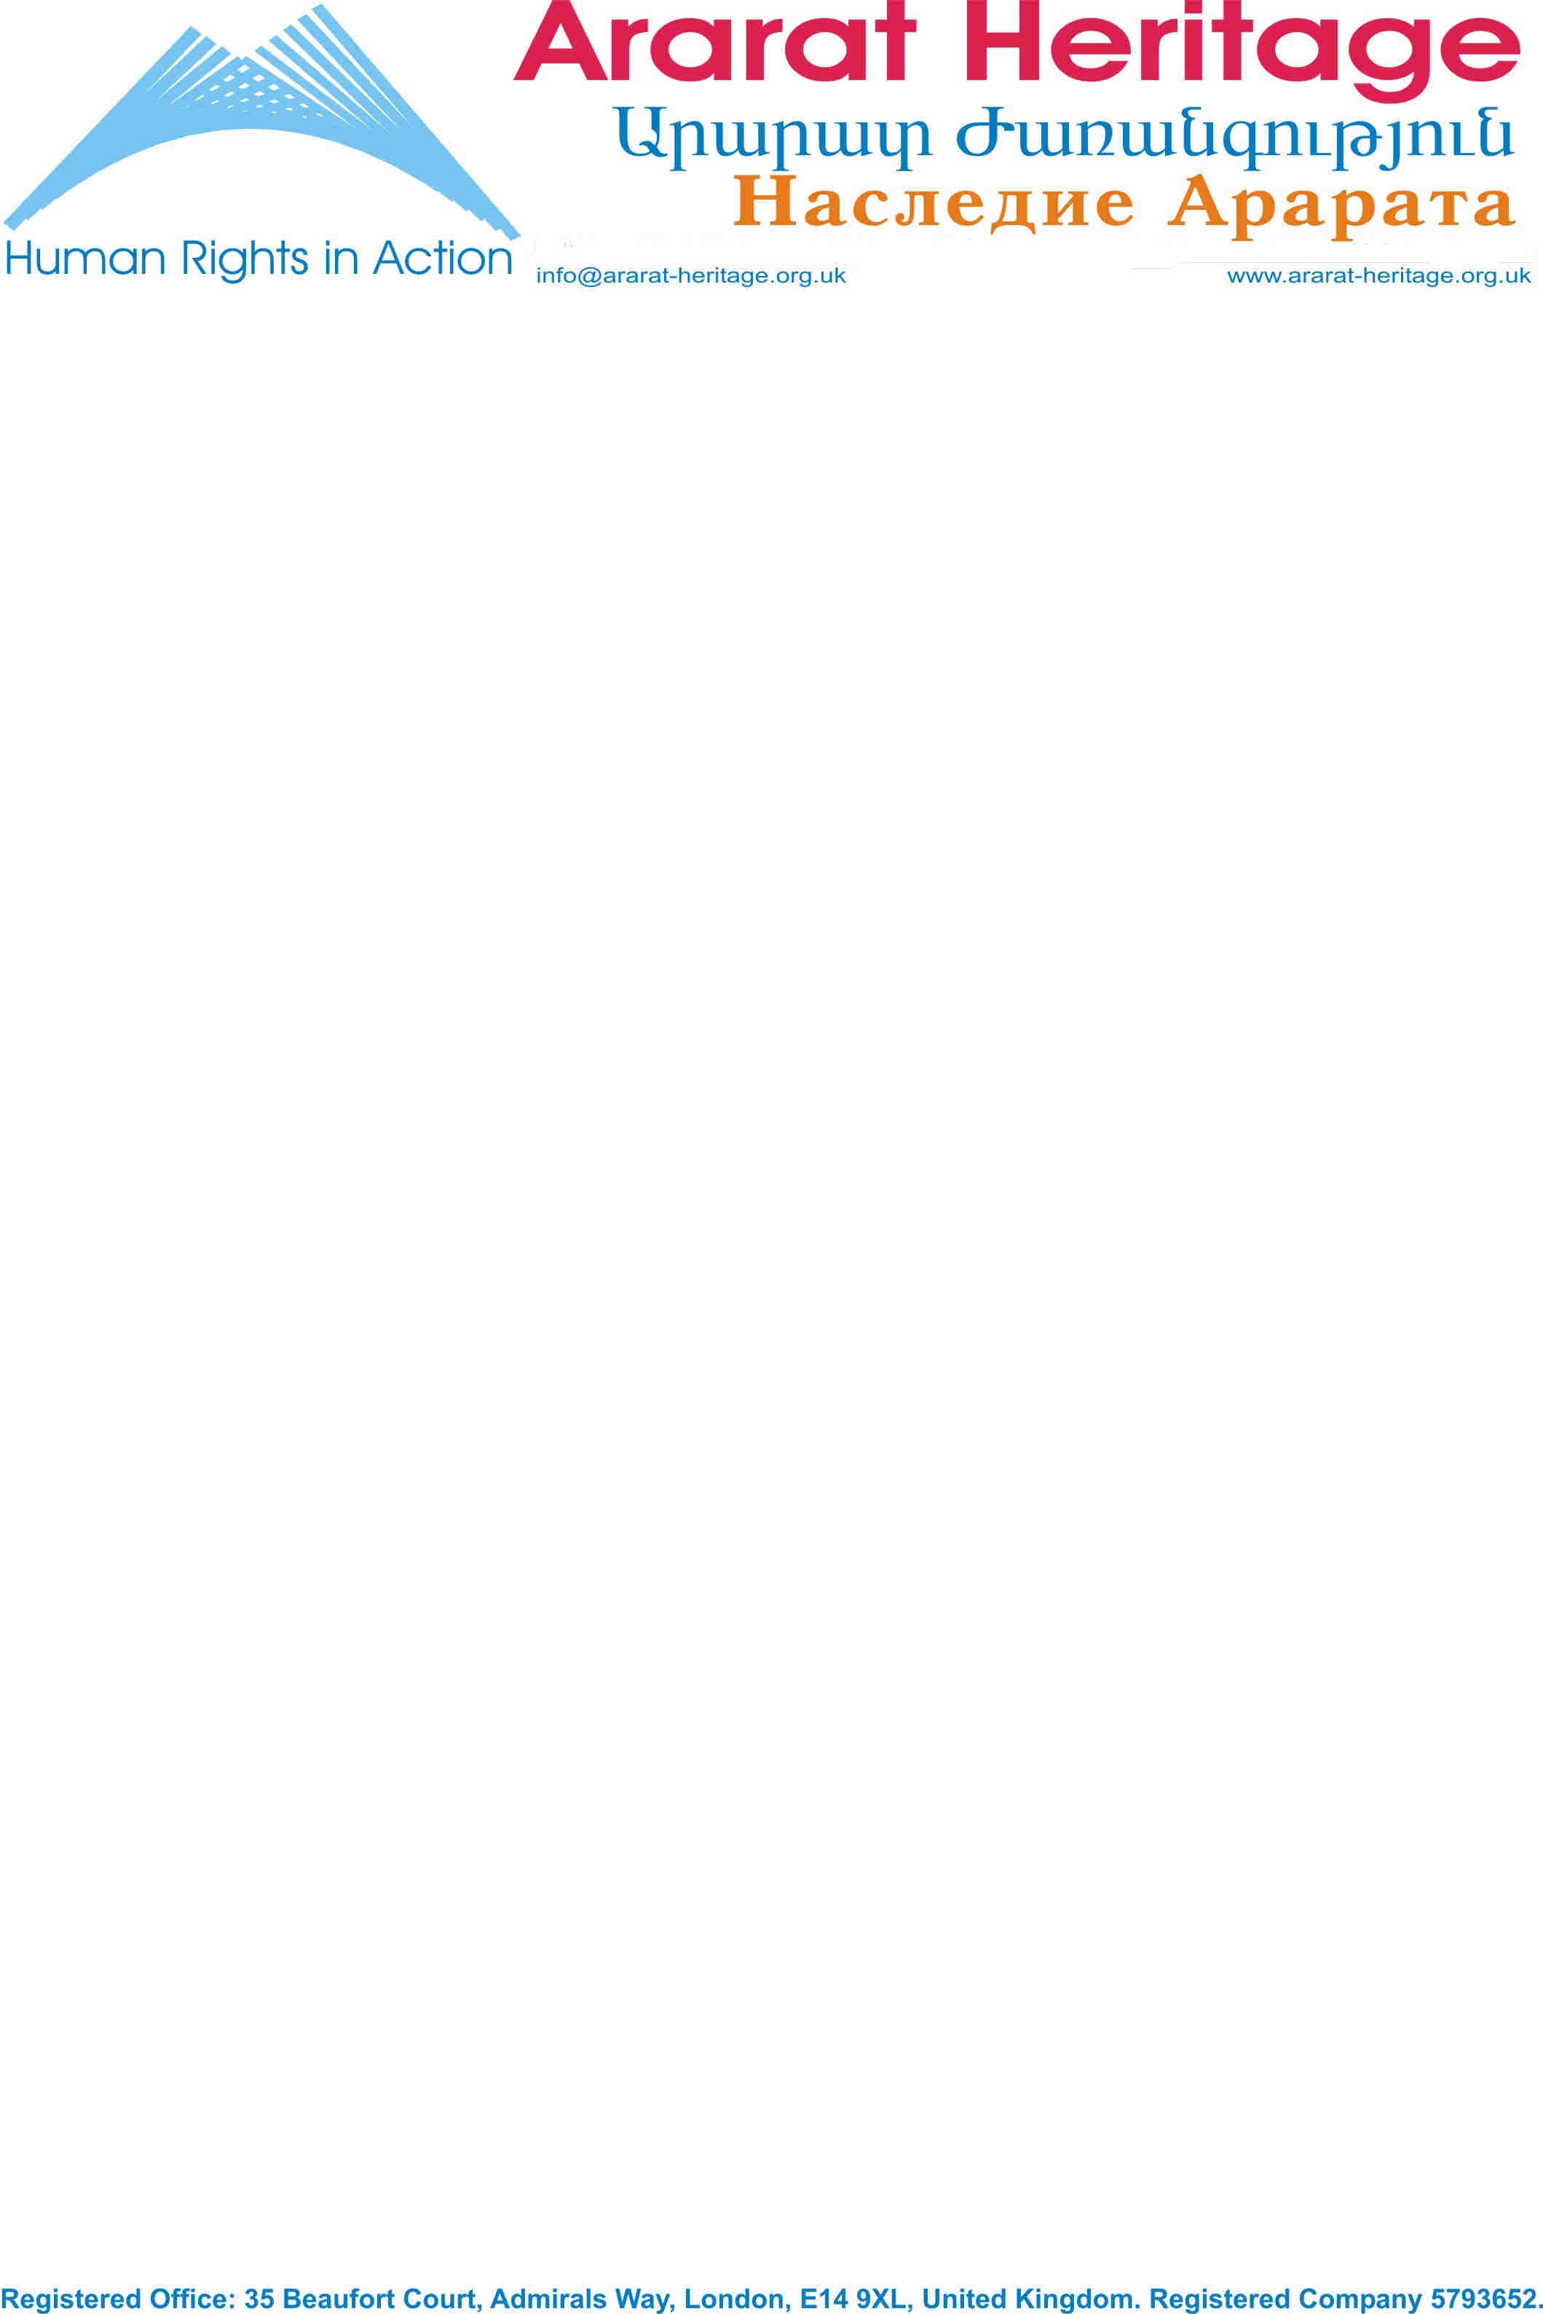

Message of Ararat Heritage to the Kashatagh Conference of 28-30,March 2008,
Conveyed by our Director Bagrad Nazarian:

Firstly, we would like to wish all the success to the Conference.

We would like to make three points:

1). Talking publicly and privately of handing territory over to Azerbaijan by the governments of Republics of Armenia and Artsakh must end permanently. This stance is significantly demoralising for the Armenian population and undermines investments and repopulation of regions. It also undermines European Continental and Iranian securities. Hence forth, if possible, talks must be gradually directed to the recovery of Nakhichevan, Artsvashen and Northern Shahumyan regions.

2). Due to the massive increase in price of agricultural produce recently throughout the world, it is imperative that cash crop such as wheat and sunflower are planted extensively for export. There is a large market for them in Iran. Thus, the income will be in dollars.

3). Armenians, inclusive of their Diaspora, have only a few experts regarding professional agricultural industrial development. It is going to be necessary to develop mass agriculture by bringing in professional companies from abroad, possibly from North and South America. Thus Armenian territories will benefit significantly from their extensive investments. However, they are going to require a secure legal and commercial environment, plus a realistic transport system.

ADENDA:

Nakhichevan and Transport Access:

The Eastern section of the Plateau of Armenia, due to its mountainous formation, has a transport problem between its Northern and Southern regions. The only realistic route is through Nakhichevan, which is an indivisible part of the said Plateau. Consequently, it is now necessary to promote its recovery.

Tony S. Kahvé
Chairman
Ararat Heritage
26th March 2008

